“Craft brewers assert their independence as fireworks erupt over who’s making the beer.”

* Brewers Association has announced the launch of a new seal to designate beers that are produced by "independent" craft brewers.
* BA's definition of "craft brewer" are those with an annual production of 6 million barrels or less and less than 25 percent ownership or control by a non-craft entity.
* Some think the label is divisive and unnecessary, and won't add value for beer drinkers.

[Tom Rotunno](https://www.cnbc.com/tom-rotunno/) | [@TomRotunno](https://twitter.com/TomRotunno)

Sunday, 2 Jul 2017 | 3:02 PM ETCNBC.com

|  |  |  |  |  |
| --- | --- | --- | --- | --- |
|  |  |  |  |  |

[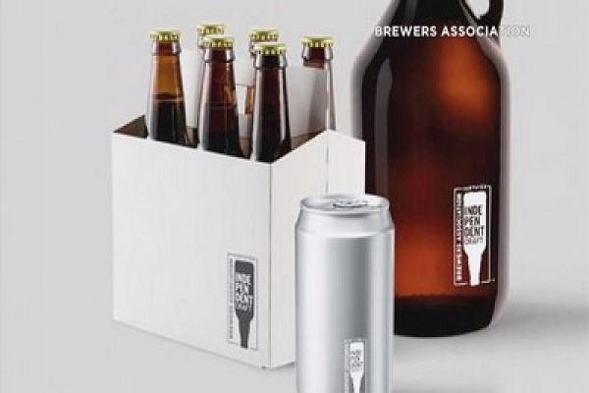](https://www.cnbc.com/video/2017/07/03/craft-brewers-assert-their-independence-as-fireworks-erupt-over-whos-making-the-beer.html)

[Craft brewers assert their independence as fireworks erupt over who's making the beer  Monday, 3 Jul 2017 | 8:16 AM ET | 00:52](https://www.cnbc.com/video/2017/07/03/craft-brewers-assert-their-independence-as-fireworks-erupt-over-whos-making-the-beer.html)

When it comes to the beer business, the Fourth of July weekend is as big as it gets, with consumers spending a billion dollars on beer by some estimates. So, perhaps it's fitting that as beer drinkers reach for a few cold ones this weekend, there are fireworks erupting over "independence" in the beer industry.

The Brewers Association (BA), the nonprofit trade group which represents "small and independent" craft brewers, has announced the launch of a new seal to designate beers that are produced by "independent" craft brewers. Craft brewers are an increasingly popular segment of the $107 billion U.S. beer market, comprising around 1/5 of brew sales in 2016.  
  
The seal—a beer bottle flipped upside down with the words "certified independent craft"—is aimed to "capture the spirit with which craft brewers have upended beer, while informing beer lovers they are choosing a beer from a brewery that is independently owned" according to the BA.  
  
The seal will be made available free of charge to any of the over 5300 craft breweries in the United States which meet the BA's [definition of "craft brewer."](https://www.brewersassociation.org/statistics/craft-brewer-defined/) Those requirements include annual production of 6 million barrels or less, and less than 25 percent ownership or control by a non-craft entity.   
  
The "certified independent" seal will appear on packaging, retail displays and in brewery communications and marketing materials. The move comes as craft brewers face increasing pressure in the marketplace.  
  
Total production volume growth of BA defined craft beer slowed to six percent growth in 2016, marking the first time in several years the segment did not post double digit growth. Further complicating matters is the fact there are a record number of breweries in operation, and more on the way. It's making the competition for distribution, shelf space and tap handles as fierce as ever.

'The 'Big Beer' effect

But the BA's introduction of the "certified independent craft" seal is designed to combat competition of another sort.  
  
Many craft brewers have called into question what it really means to be "craft" in an era of global brewing giants, derisively called 'Big Beer' by some critics, buying smaller brewers. A stark example is [Anheuser-Busch InBev](https://www.cnbc.com/quotes?symbol=ABI-BE), which has [purchased](https://goo.gl/xoHfVZ) 10 breweries since 2011.   
  
"As 'Big Beer' acquires former craft brands, beer drinkers have become increasingly confused about which brewers remain independent" said Bob Pease, president & CEO, Brewers Association in a statement. "This seal is a simple way to provide that clarity—now they can know what's been brewed small and certified independent."  
  
The move was applauded by many long-standing members of the craft brewing community, and within days of its introduction more than 800 breweries have applied to license the seal for use.

"Our fans tell us all the time how important it is to them to know that Stone is steadfastly independent" said Greg Koch, co-founder and executive chairman of California based Stone Brewing Co.

"There are clear threats from wine and spirits out there that, whether we are being willful and not noticing that or we are too busy fighting amongst ourselves."-Andy Ingram, founder, Four Peaks Brewing

"We realize that it can be a confusing world out there with a great deal of obfuscation and "pay no attention to the man behind the curtain" tactics of big beer," he added.  
  
Rob Tod, founder of Allagash Brewing Company in Portland, Maine and chair of the Brewers Association board of directors, made his case for why independence matters.  
  
"When beer lovers buy independent craft beer, they are supporting American entrepreneurs and the risk takers who have long strived not just to be innovative and make truly great beer, but to also build culture and community in the process" he said in a statement.  
  
However, some other brewers say the BA seal is divisive, at a time when brewers need to be coming together in the wake of the overall beer segment losing market share to wine and spirits.  
  
"There are clear threats from wine and spirits out there that, whether we are being willful and not noticing that or we are too busy fighting amongst ourselves, there is a clear present danger out there," said Andy Ingram, founder of Four Peaks Brewing in Tempe, Arizona which was purchased by Anheuser-Busch in 2015.  
  
While many brewer's big and small argue over the labels and definitions, the question remains whether or not the seal will have any cachet with consumers when it comes time to buying their brew.  
  
A recent study commissioned by beer-industry trade publication Brewbound.com and conducted by Nielsen, suggests it could—at least among those who define themselves as "regular craft beer" drinkers.  
  
The study looked at 29 words commonly used to market beer, with the term "independently owned" among the top words that drove purchasing decisions among craft beer drinkers.  
  
Still, Chris Furnari, the editor of Brewbound.com isn't totally convinced the seal will be game changer when it comes to purchasing decisions.  
  
"A small group of consumers will [be swayed], but most mainstream drinkers will likely choose products and brands that appeal to them on levels that go beyond ownership" he said.

Furnari views the seal as a missed opportunity by the BA to ensure the quality of the breweries that choose to use it. At a minimum, he said the BA should require date coding on all packaging, to let the buyer know how fresh the product is.  
  
"I am disappointed that the BA has seemingly chosen to prioritize ownership over quality when introducing this seal" he said.  
  
With the seal set to begin appearing on packaging in the coming months, the debate over "independence" in craft is sure to continue, something Walt Dickinson of North Carolina based Wicked Weed Brewing addressed in a video statement. In May, Wicked Weed was [purchased by Anheuser-Busch's High End division](https://www.usatoday.com/story/money/nation-now/2017/05/03/wicked-weed-brewing-anheuser-busch-partnership/309733001/), its imprint for craft brands.  
  
"I was just hoping we could get back to just talking about beer, but I guess we're not there yet but hopefully soon," he added.